Disney Kids & Family Discovers Voice Talent Search 2026 Class

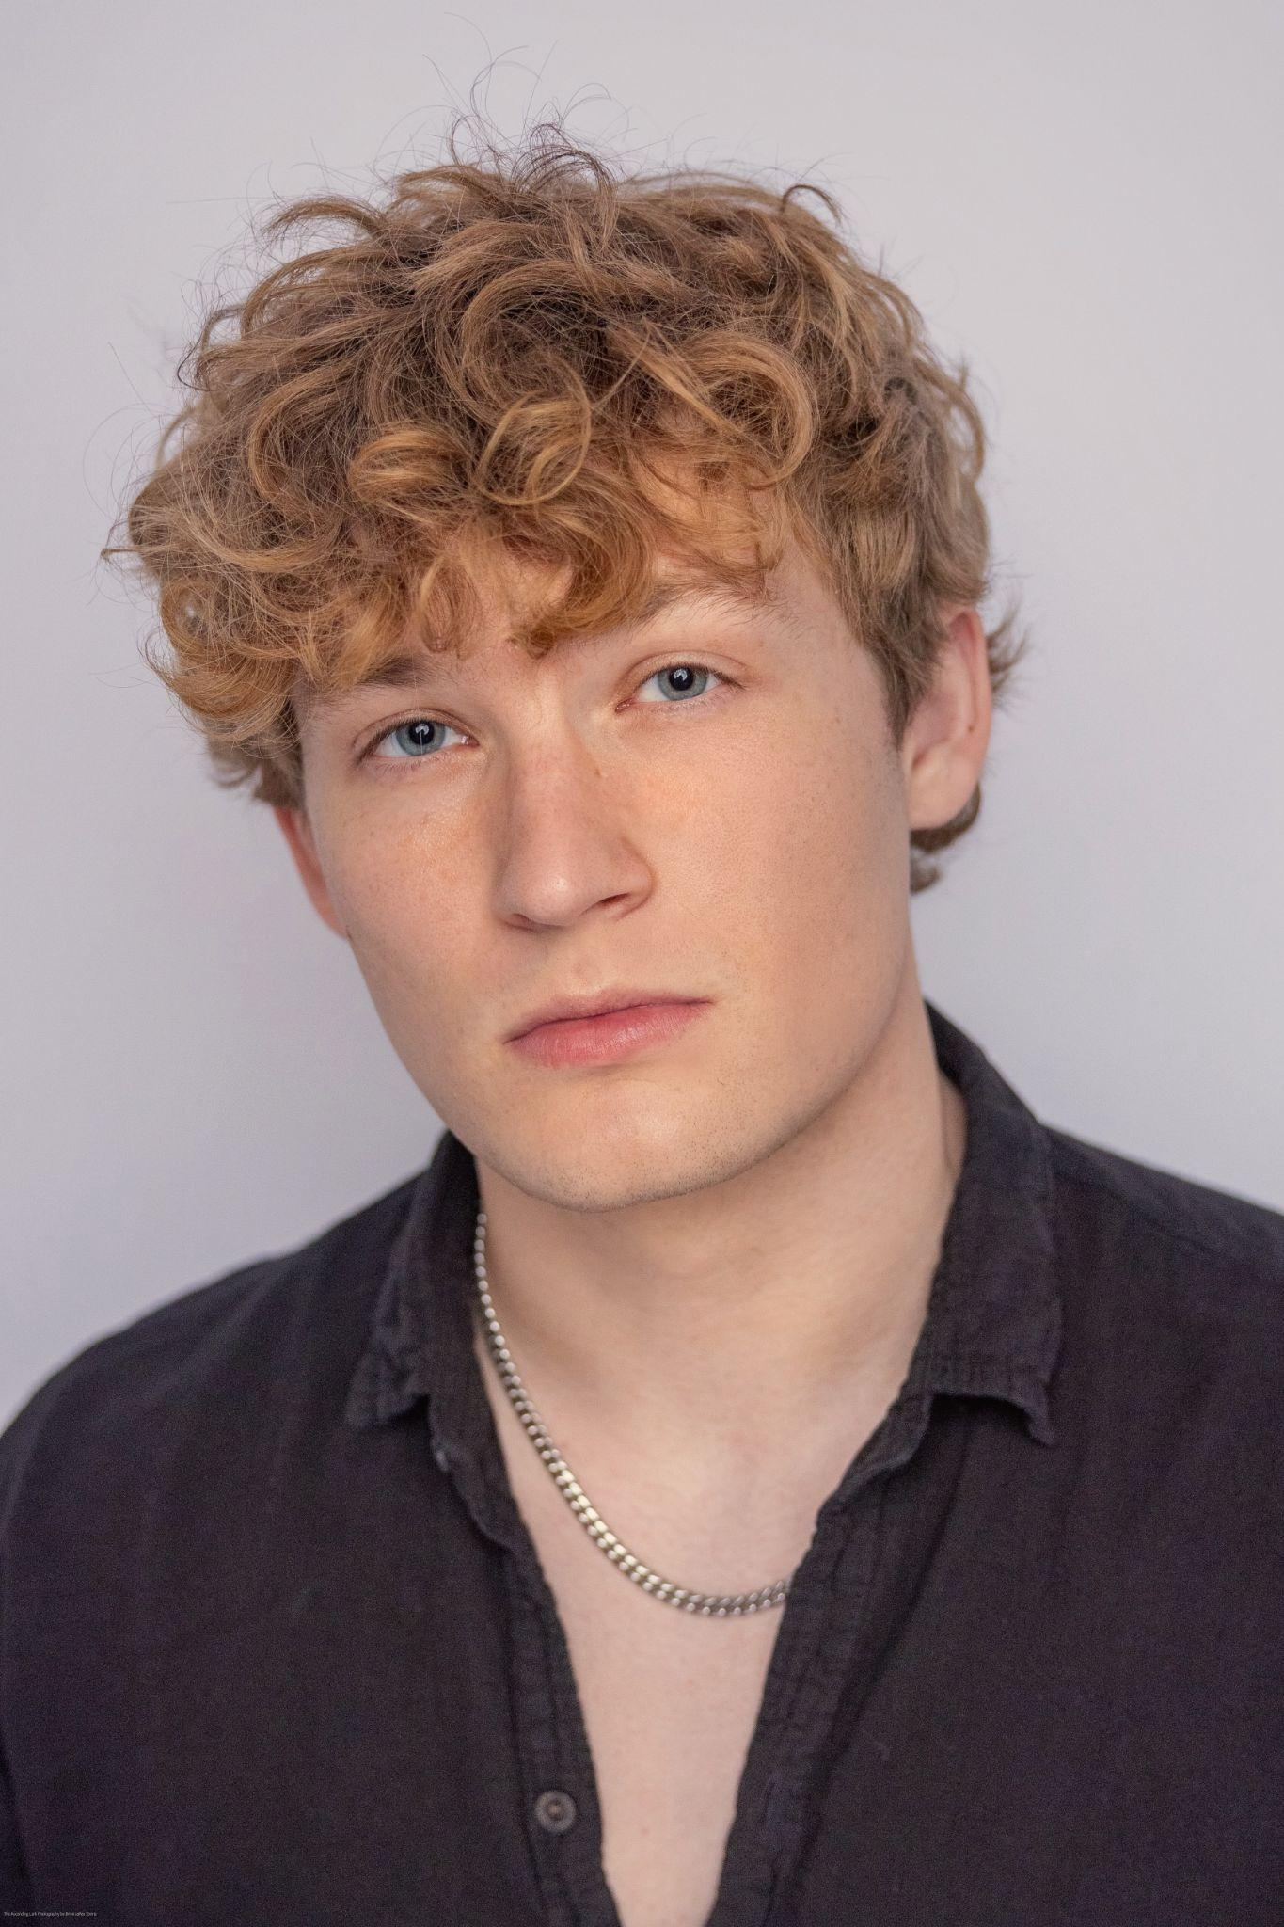
Bennett Morgan (he/him)
Bennett Morgan is an actor, writer, and theater-trained vocalist. He holds an MFA in Screenwriting from UCLA and frequently lends his high-energy voice to the animated YouTube series History Abridged. Also a filmmaker, Morgan wrote and co-stars in the upcoming dark comedy short film Night Bus. He is eager to learn from seasoned storytellers and industry professionals and looks forward to bringing new animated characters to life.

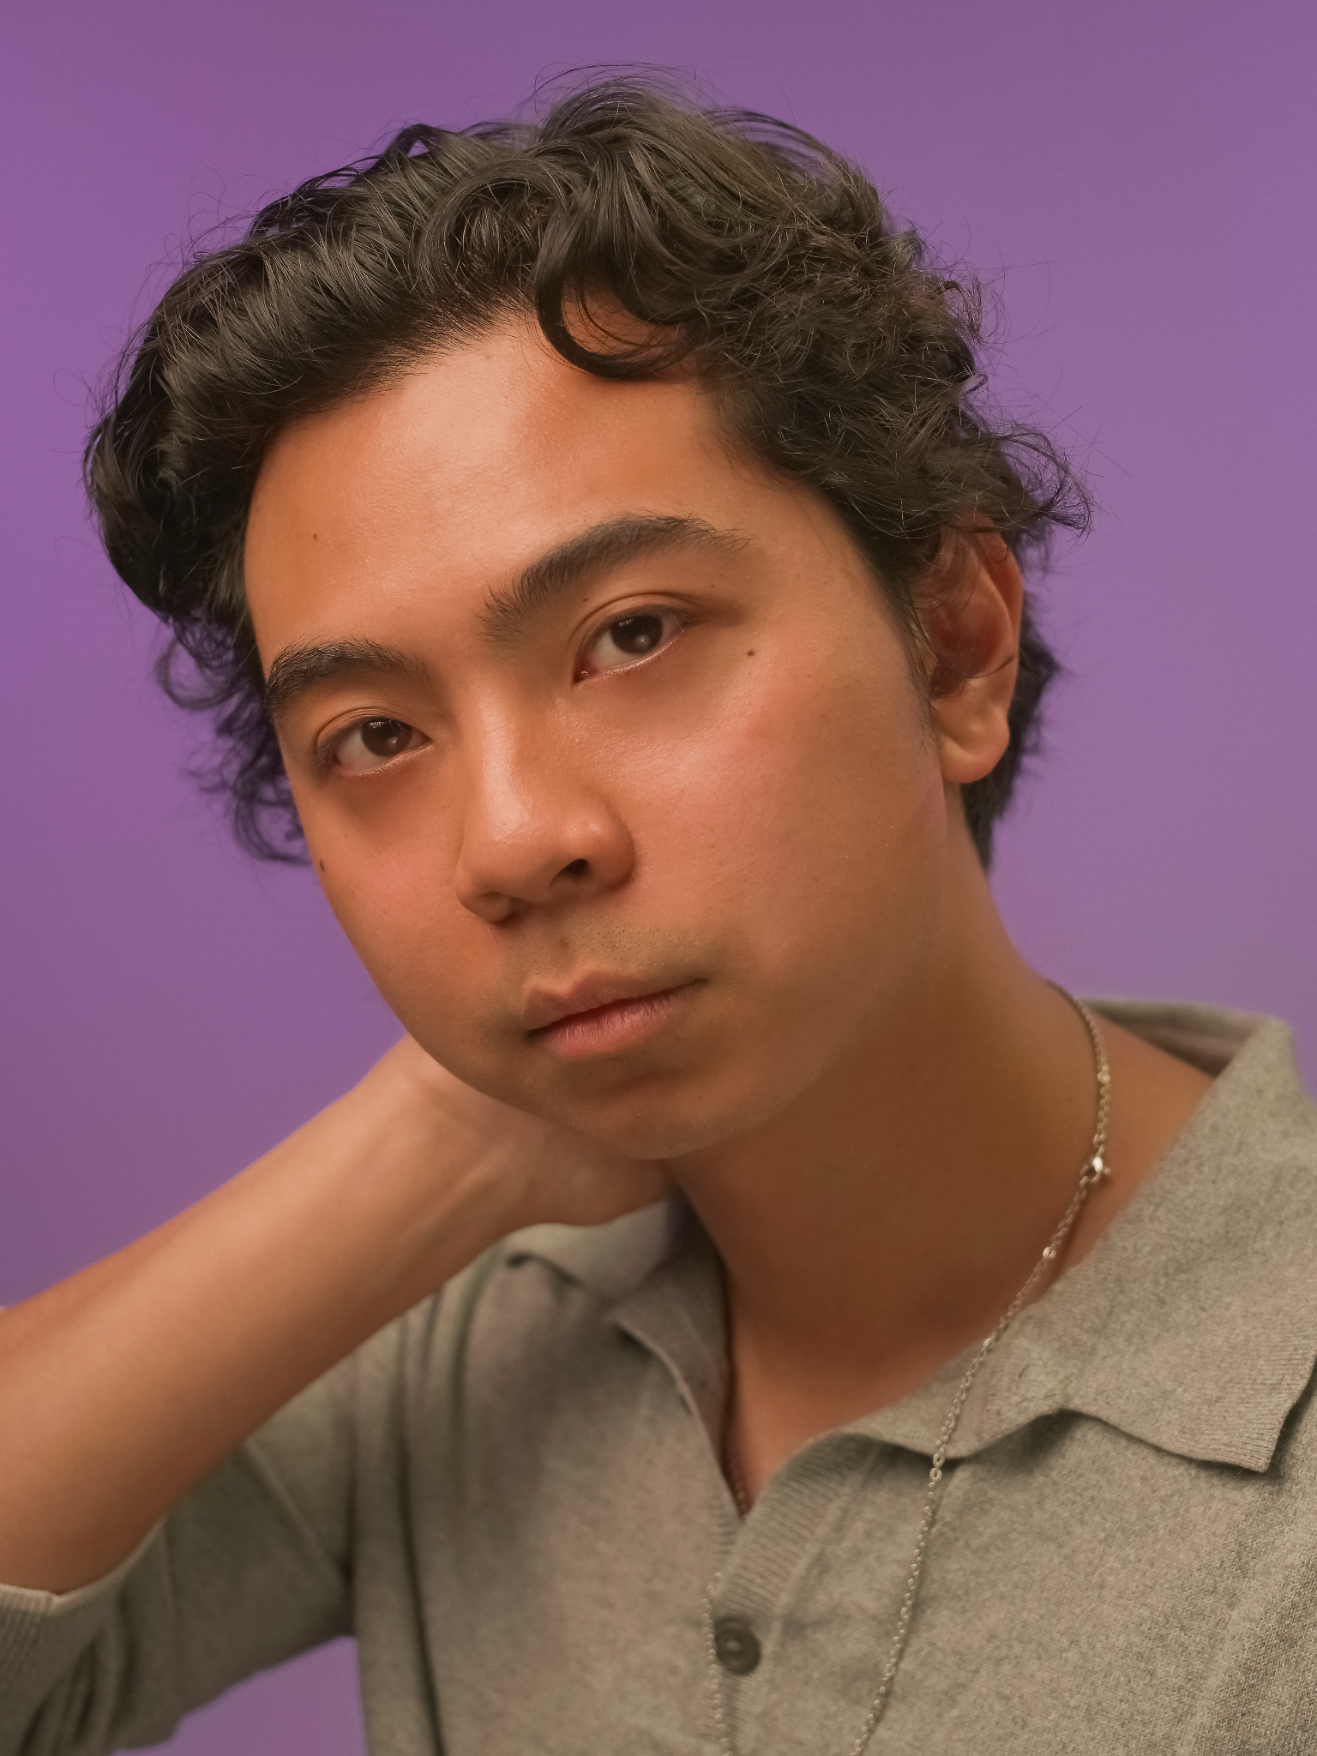
Daniel Zamora (he/him)
Daniel Zamora is a Filipino-American based actor from Houston, TX. After getting his degree in Digital Media and Theatre, he spent several years in Chicago working professionally while studying improv and theatre in his spare time. He recently returned to Houston and is now pursuing acting full‑time. In his spare time, you can find Daniel learning trapeze, reading a good fantasy novel, or on hikes with his dog, Tifa.

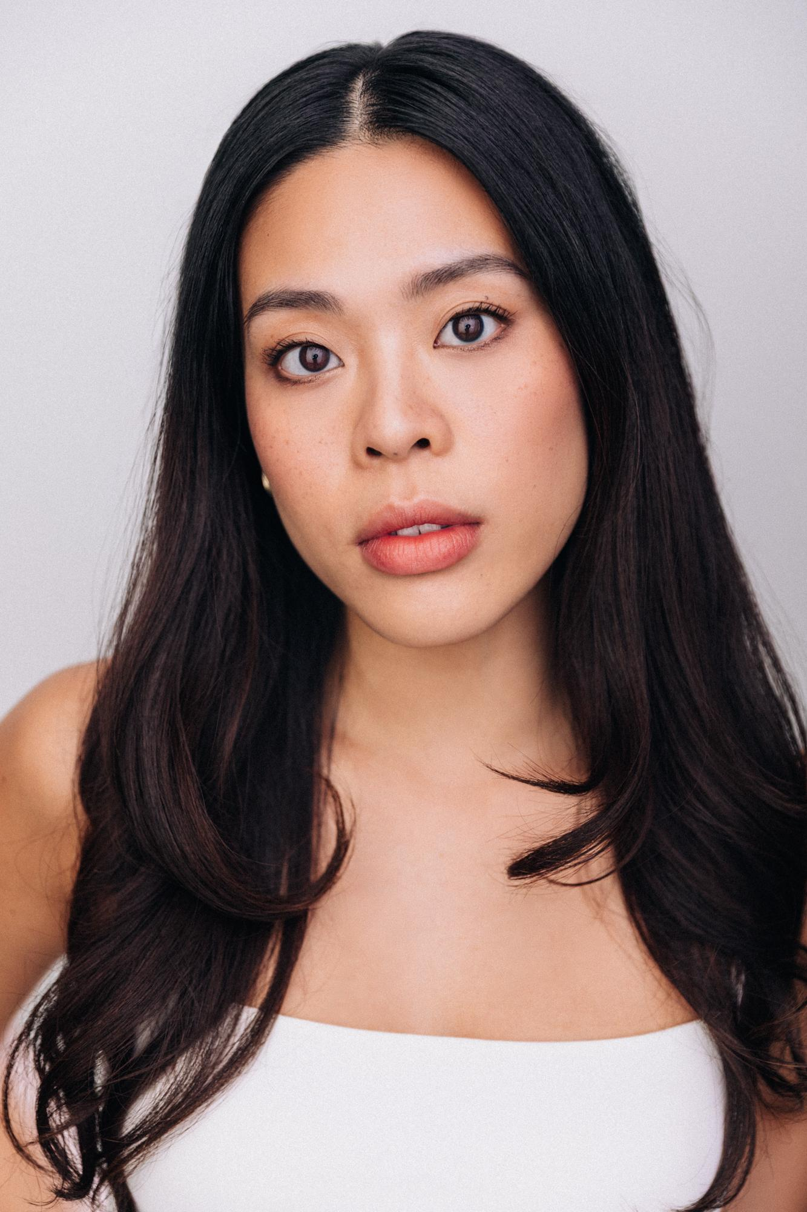
Kai An Chee (she/her)
Kai An Chee is a Malaysian-Chinese performer based in New York City whose name is pronounced like the pepper. Select theater credits include Kim Alternate in Miss Saigon (Broadway National Tour), Mr. Holland’s Opus (Ogunquit Playhouse), Lizard Boy (Off-Broadway), Madame Clicquot (Pittsburgh CLO), and workshops of Jason Robert Brown’s Farewell My Concubine and Michael John LaChiusa’s American Eclipse. On screen, she has appeared in FBI: Most Wanted, That Damn Michael Che, and Olga Dies Dreaming. Her voiceover work includes Grand Army (Netflix), Big Hearts Belong (Nickelodeon), Ray Ban, Blistex, and more. As a third culture kid, she loves to travel and learn new languages, and can often be found spending time with her cat. She is represented by Rebel Creative Group.

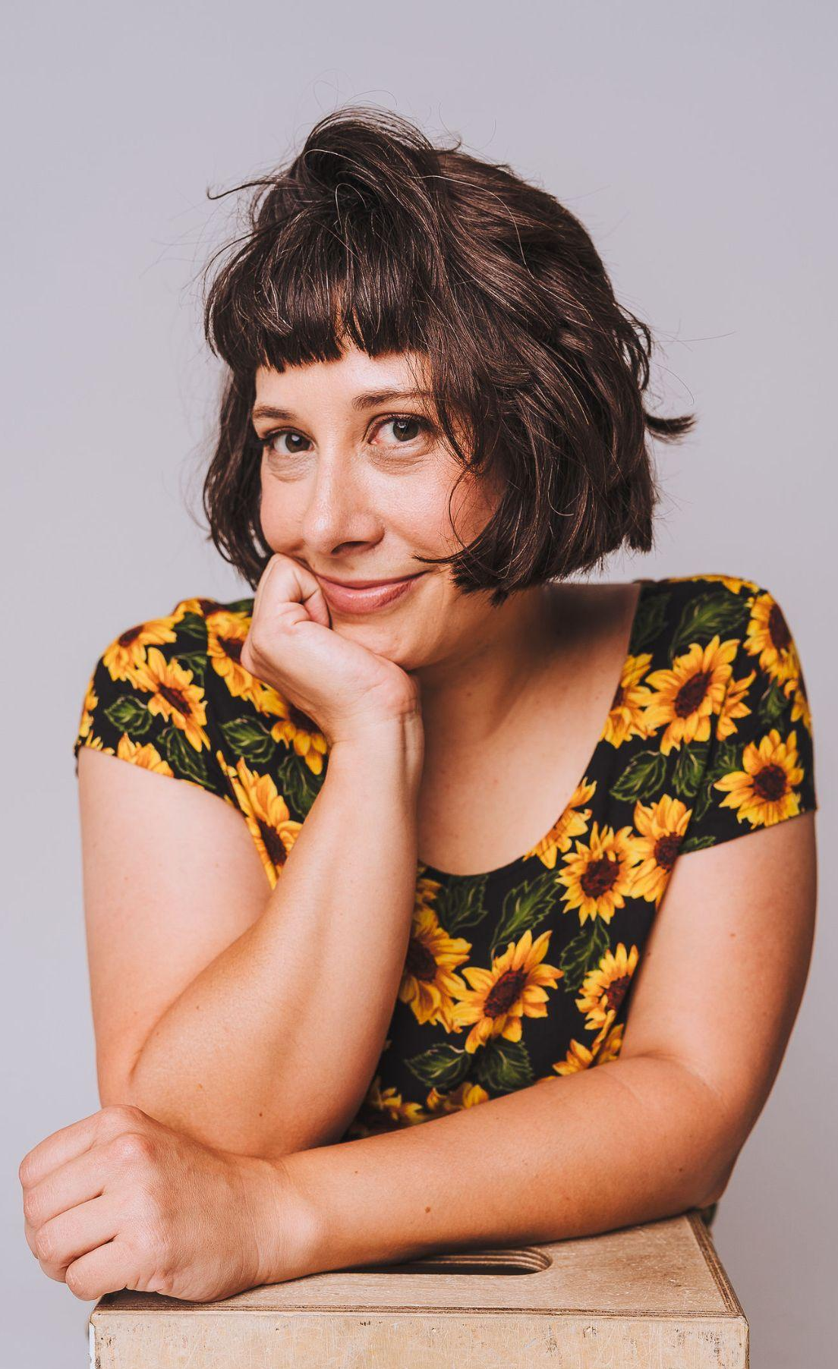
Kristina Mueller (she/her)
Kristina Mueller is an actress, VO artist, writer, and director based in Los Angeles, CA. Raised half in the beautiful city of Munich and half in the States, she is fluent in both English and German. She is an NYU/Tisch and RADA (London) alum and a founding member of Monday Nights Theatre Co. You might have seen her as Rose in Grasses of a Thousand Colors by/starring Wallace Shawn at The Public Theatre, heard her as various evil sharks in Seal Team (Netflix), or overheard that she just finished directing her first short film, SHED. Kristina loves Shakespeare, will eat anything in pickled form, and makes a mean créme brulée.


Luke Alphonso (he/him)
Luke Alphonso is a Louisiana man transplanted into Colorado, and he's been loving the outdoor life ever since. When he's not in his voice booth, Luke is an enjoyer of snowboarding during the winter and IPAs during the summer, cruising downtown with his longboard, or scaling the peaks of the Rocky Mountain Range. Luke is an avid horror fan and has been overjoyed at the new onslaught of classics coming out this summer, along with curling up with his favorites like Evil Dead, Resident Evil, and Dead Space. Some of his favorite inspirations for the booth come from shows like Futurama, Samurai Jack, Arrested Development, Better Call Saul, and Black Mass.

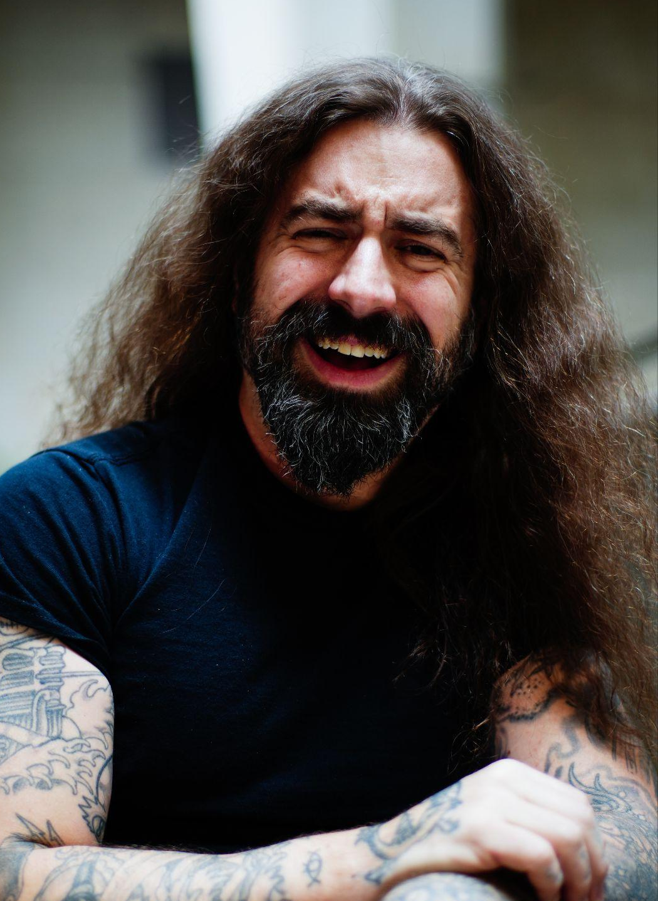
Mark Douglas S. (he/him)
Mark Douglas S is a voice actor, musician, and loveable ne’er-do-well from the Emerald City of Seattle, Washington. He has been featured in several video games, Webtoon comics, audio dramas, and the actual-play podcast, Leastwatch. When not in the booth, Mark can usually be found riding his bicycle or hiking amongst the forest goblins. Don’t worry, he’s not sure what he’s doing here either.

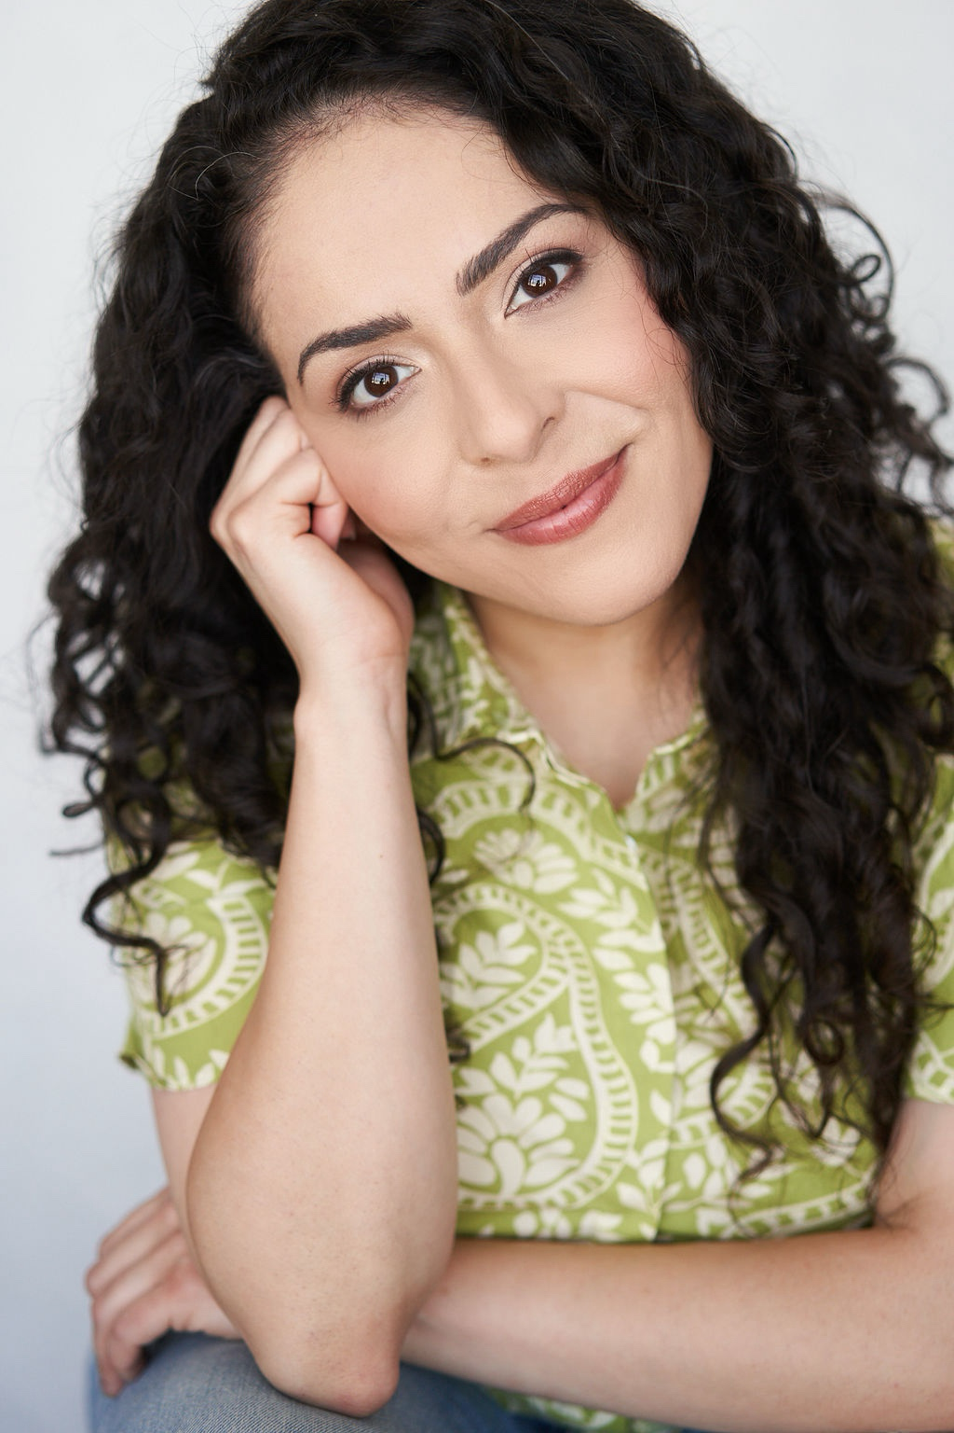
Nadia Vazquez (she/her)
Nadia Vazquez is an actor, singer, writer, and improvisor. She trained at NYU’s Tisch School of the Arts, Stella Adler Studio of Acting, UCBLA, and The Groundlings. While her corporeal form has been seen on TBS’s Conan, her voice has been heard in national commercial campaigns (Yoplait), narrative podcasts (Red Rhino, Don’t Write Me Off, and Earth Crew 2042), and video games (GODDESS OF VICTORY: NIKKE, Shadowverse). Nadia is also a voice over coach and served as the Spanish-language consultant on Aubrey Plaza’s Emily the Criminal. Her writing has been featured on Huffington Post Comedy, Hulu, Sci-Fi Snack Shop, and more. She has an orange cat.

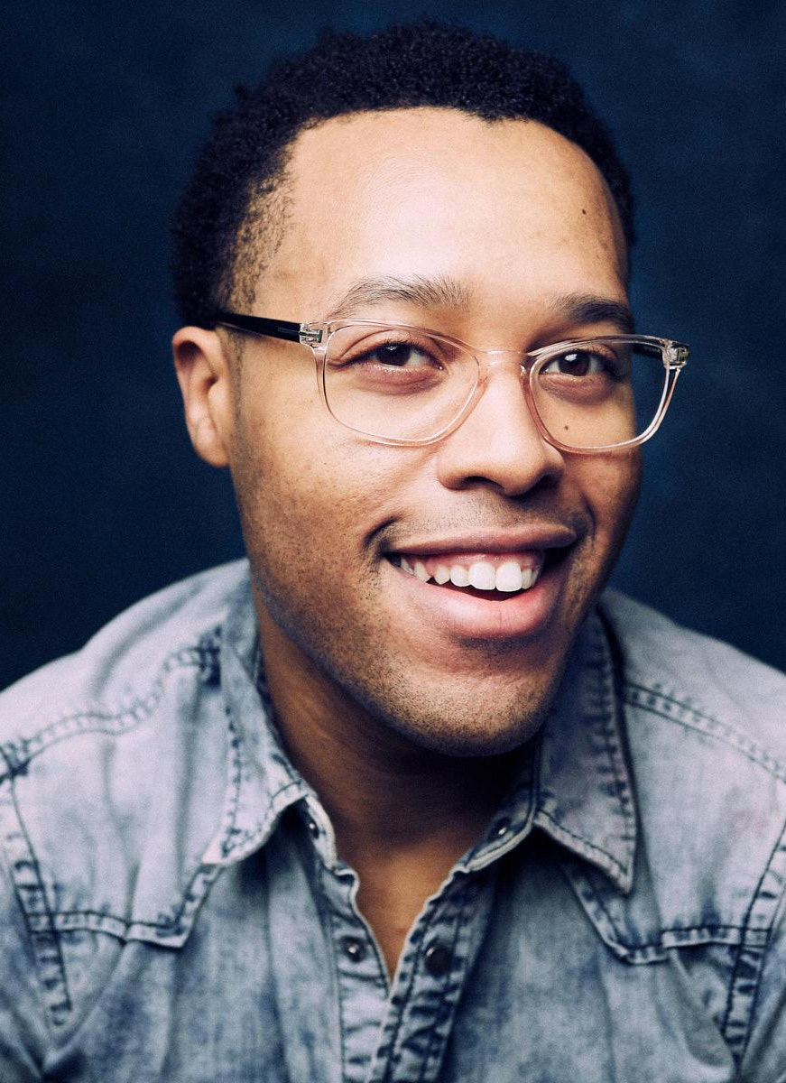
Neptune of Earth (he/they)
Born in Washington, D.C. and raised between D.C. and LA, Neptune’s journey began with music, performing with the acclaimed Gibson/Baldwin Grammy Jazz Ensemble in high school. They went on to train with the Boston Conservatory at Berklee before embarking on an impressive stage career on and off-Broadway in shows like Motown the Musical, Beautiful: The Carole King Musical, and Stephen Sondheim’s Merrily We Roll Along. Tune has also played multiple roles in Hamilton, including Aaron Burr, King George lll, George Washington, and Thomas Jefferson. On screen, their standout appearances include Queen of Knives, Law & Order: SVU, and God Friended Me.

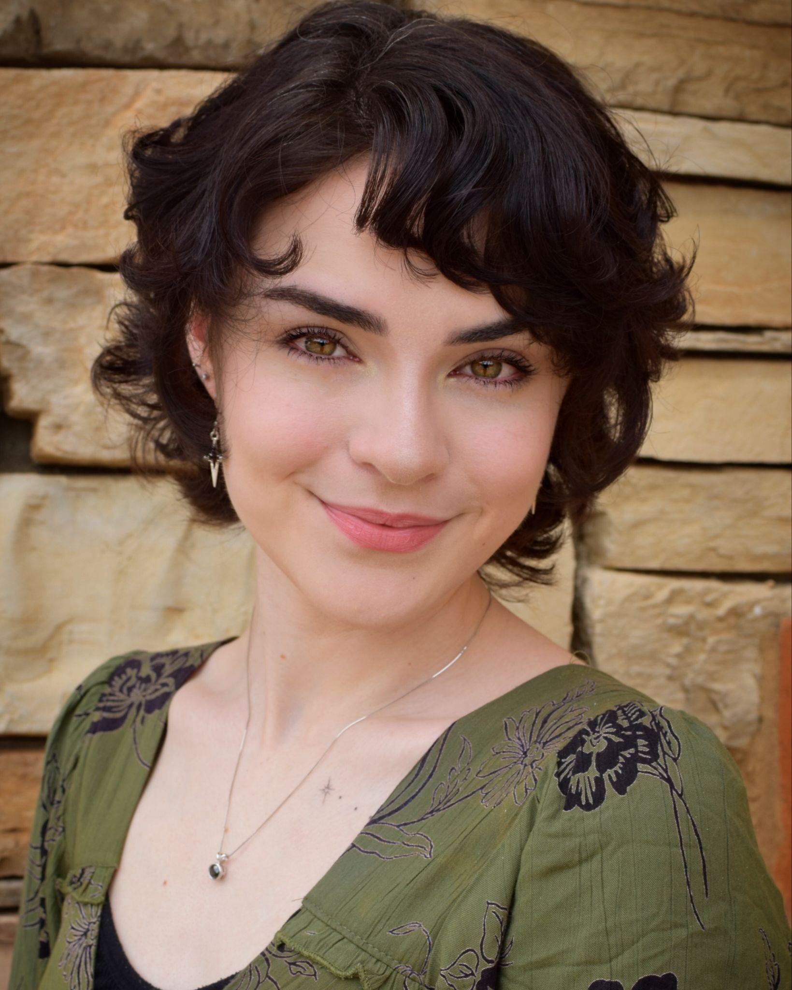
Parker Paige (they/she)
Parker Paige has been professionally pursuing acting since they were 14 years old. Their love for performing and voice acting started the moment Parker learned how to speak. From low-budget short films to background work in movies and TV to lead voice over roles in video games, Parker loves any and every form of acting. When not behind the mic, Parker can be found practicing Muay Thai or making a new wig and costume for a Cosplay Convention. Parker has a deep passion and love for the art of acting, and they're eager to make their dream a reality.

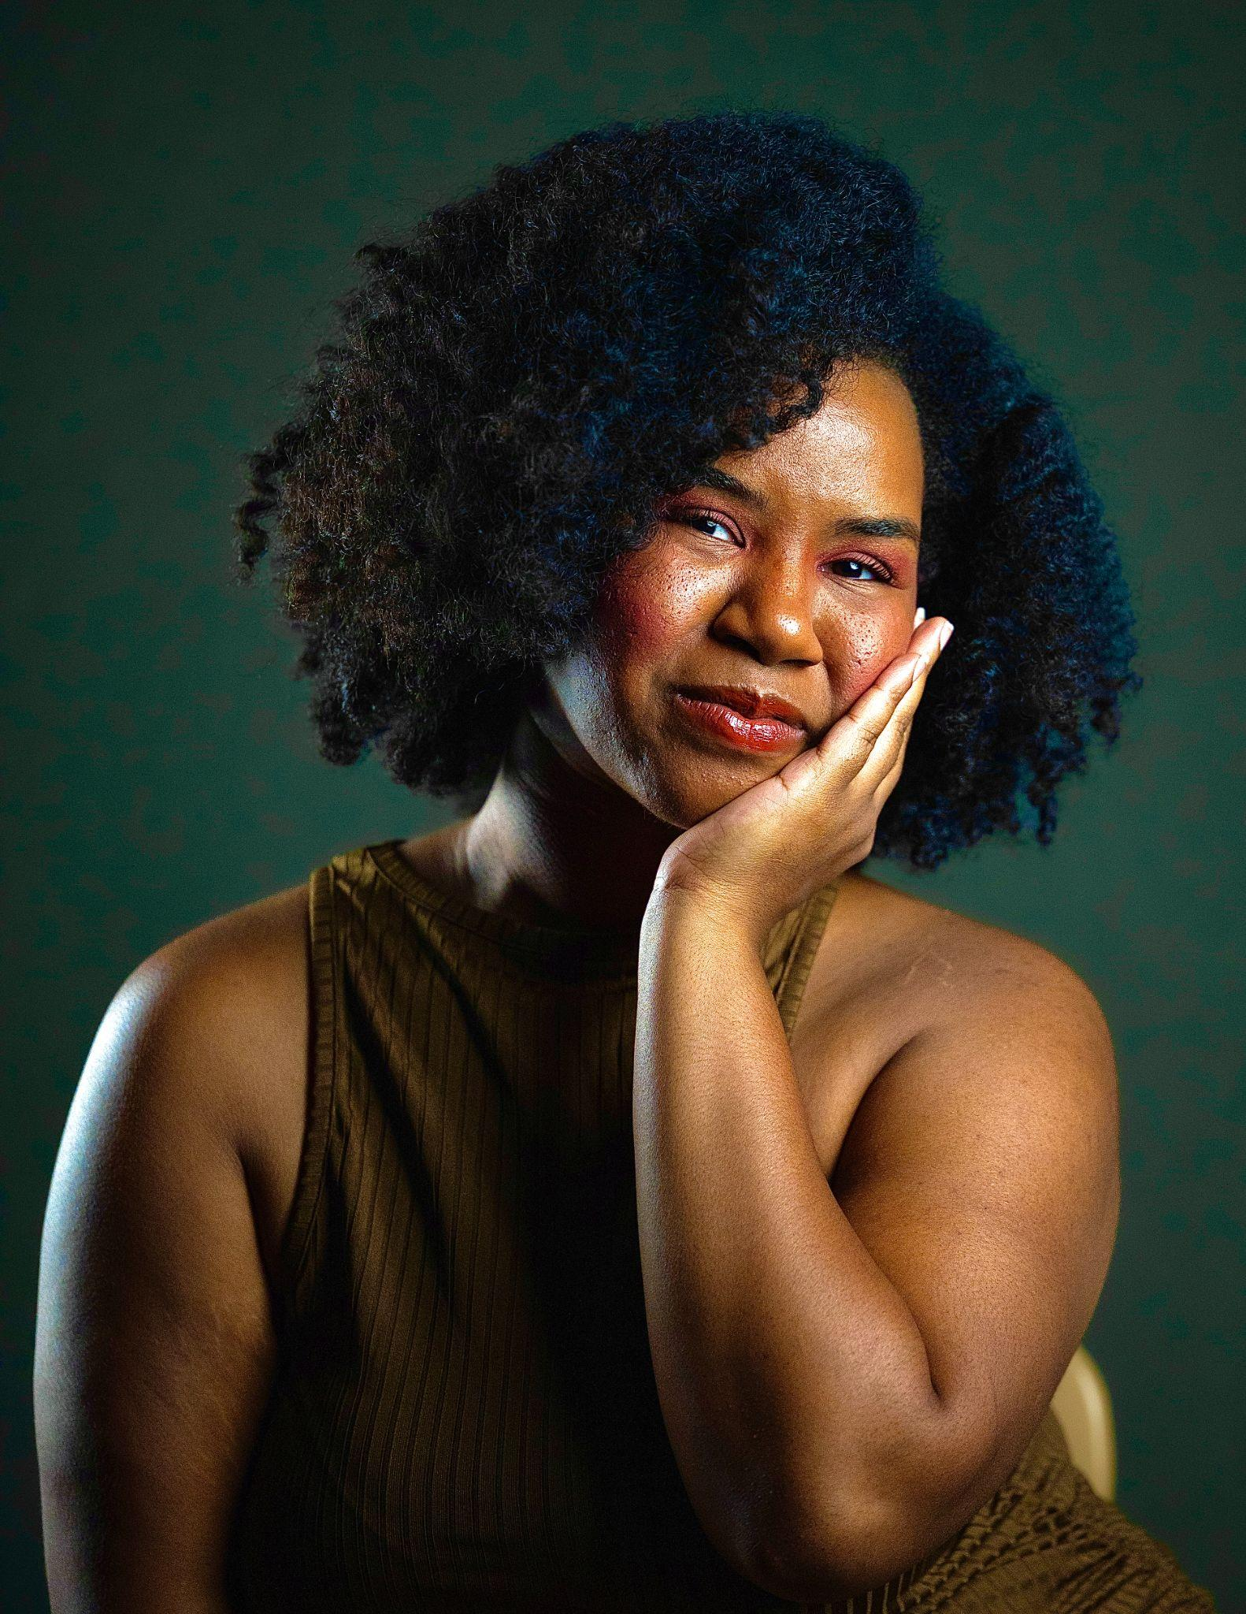
Varyssa Henderson (she/her)
Varyssa Henderson is a Durham, North Carolina native and performer whose work has primarily focused on musical theatre. Her credits include Beehive: The 60’s Musical, The Wiz, and Once on This Island. Most recently, she attended the International Thespian Festival as a masterclass instructor and adjudicator for emerging performers. A lifelong Disney fan, Varyssa is honored to collaborate with Disney and excited to help create stories that inspire audiences of all ages.

